**Debugging Test scripts from VS**

**Step 1:**

Click Run and debug Icon from VS code.

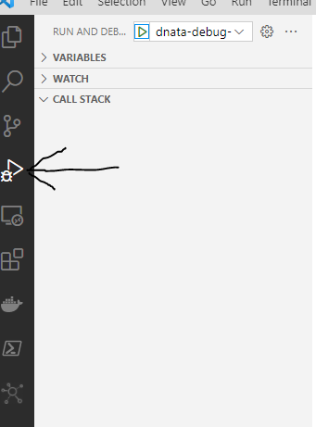

**Step 2:** Create launch.json file, if it is not created.

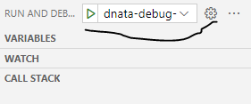

**Step 3:**

Add given below content in launch.json file

{

    // Use IntelliSense to learn about possible attributes.

    // Hover to view descriptions of existing attributes.

    // For more information, visit: https://go.microsoft.com/fwlink/?linkid=830387

    "version": "0.2.0",

    "configurations": [

        {

            "name": "dnata-debug-config",

            "type": "node",

            "request": "launch",

            "args": ["./test/wdio.conf.ts","--spec=./features/HotelsEnd2End.feature"],

            "cwd": "${workspaceFolder}",

            "autoAttachChildProcesses": true,

            "program": "${workspaceRoot}/node_modules/@wdio/cli/bin/wdio.js",

            "console": "integratedTerminal",

            "skipFiles": [

                "${workspaceFolder}/node_modules/**/*.js",

                "${workspaceFolder}/lib/**/*.js",

                "<node_internals>/**/*.js"

            ]

        }

    ]

}

** Please note: We can debug suite, single feature file after updating spec path

**Step 4:** Add breakpoint in any method and debug the scripts

